Emergency Operations and Action Plan

“Emergency Plan” for

Enter location name

Location Name | Enter response
Location Type | ☐ Parish ☐School ☐Preschool ☐Other: Enter response
Address | Enter response
Person in Charge | Enter response
Plan Administrator | Enter response
Date Adopted Select date | Enter response
Next Review Date Select date | Enter response

- Purpose and Scope
Purpose. The purpose of this Emergency Plan is to protect life, reduce harm, support orderly decision-making, coordinate response actions, maintain continuity of essential ministry and educational functions, and promote timely recovery following an emergency. Response priorities are life safety, incident stabilization, accountability, protection of vulnerable persons, continuity of critical operations, family reunification, and recovery.
Scope. This plan applies during school hours, before- and after-school programs, liturgies, religious education, office operations, events, ministries, athletic activities, and other school or parish functions occurring on campus or under school/parish supervision.

- Concept of Operations
This Emergency Operations and Action Plan establishes procedures for prevention, protection, mitigation, response, and recovery for emergencies affecting parish operations, school operations, worship services, ministries, students, staff, volunteers, visitors, and contractors. It is designed to satisfy the requirements for an emergency operations plan for schools and houses of worship and a workplace emergency action plan. It uses an all-hazards framework and should be read together with the attached Emergency Plan Instructions.

- Emergency Organization and Roles
Function | Primary | Alternate | Phone / Email
Person in Charge | Enter response | Enter response | Enter response
Plan Administrator | Enter response | Enter response | Enter response
Safety / Security Lead | Enter response | Enter response | Enter response
Communications Lead | Enter response | Enter response | Enter response
Medical / First Aid / AED Lead | Enter response | Enter response | Enter response
Facilities / Utilities Lead | Enter response | Enter response | Enter response
Recordkeeping / Accountability Lead | Enter response | Enter response | Enter response
Family Reunification Lead | Enter response | Enter response | Enter response

Lines of succession: Enter responseEnter response___
[For example: If one or more of the persons identified above is not available, the next person in line should assume the absent person’s (or persons’) responsibilities.]
Employees may contact the following person(s) for more information about this plan or for an explanation of assigned duties: Enter response___.
Emergency Contact Directory
Contact | Name / Agency | Phone | Notes
Emergency Services | 911 | 911 | Use for immediate threat, fire, medical emergency, or crime in progress.
Local Police / Sheriff | Enter response | Enter response | Enter response
Fire Department | Enter response | Enter response | Enter response
AED Trained Cardiac Emergency Responder (athletic events) | Enter response | Enter response | Enter response
Archdiocesan Contact | Enter response | Enter response | Enter response
Communications / Media Contact | Enter response | Enter response | Enter response
Insurance Contact | Enter response | Enter response | Enter response
Utility: Gas | Enter response | Enter response | Shutoff location: Enter response
Utility: Electric | Enter response | Enter response | Shutoff location: Enter response
Utility: Water | Enter response | Enter response | Shutoff location: Enter response

- Hazard, Response, and Site-Specific Notes

Hazard | Response | Site-Specific Notes
Fire/Wildfire/Smoke | Activate alarm if not already sounding; call 911; evacuate close doors if safe; account for occupants; do not re-enter until authorized by fire department. | Fire Panel Locations: Click or tap here to enter text.
Earthquake | Drop, cover, and hold during shaking; assess injuries and building conditions after shaking; evacuate if unsafe; account for occupants. | Exterior safe areas:Click or tap here to enter text.
Medical Emergency/Cardiac Event | Call 911 as needed; send trained first aid / AED responders; secure student supervision; protect privacy; document incident. | First aid kit / AED location:Click or tap here to enter text.
Hazardous Materials | Shelter-in-place or evacuate as directed; close windows and doors; shut down HVAC if directed and safe. | HVAC controls:Click or tap here to enter text.
Severe Weather | Monitor alerts; move occupants to shelter areas away from windows and large-span roofs as appropriate. | Shelter areas: Click or tap here to enter text.
Violence or Armed Intruder | Use safest option (run, hide, fight) based on the circumstances; call 911 if safe; evacuate or lockdown as directed by law enforcement; refer to attached Appendix K Workplace Violence Prevention Plan. | Lockdown announcement: Click or tap here to enter text.  Evacuation announcement:
Bomb Threat or Suspicious Item | Keep caller or threat message information; notify law enforcement; avoid radio / cell phone use near suspicious items; evacuate or shelter based on law enforcement direction. | Threat checklist location:Click or tap here to enter text.
Utility Failure | Determine if operations can continue safely; consider evacuation, relocation, early dismissal depending on lighting, HVAC, sanitation, food service, and security impacts | Contact information for utility services:Click or tap here to enter text.
Missing Child / Vulnerable Person | Notify person in charge; initiate search and accountability procedures, secure exits as appropriate, notify law enforcement promptly when warranted. | Search coordinator:Click or tap here to enter text.
Law Enforcement Activity Nearby / Civil Disturbance | Comply immediately with any official orders, curfews, or traffic directions issued by public safety authorities.  Do not engage: never approach, confront, or attempt to talk to protestors, crowds, or law enforcement personnel involved in an action.  Secure all exterior doors and windows, but do not block primary emergency escape routes if an evacuation becomes necessary | Exterior doors / Gates assigned to: Click or tap here to enter text.
Transportation / Field Trip Incident | Follow response measures appropriate to the incident. Refer to: 12.3.1 - Field Trip Policies for Parishes and Schools. | Follow field trip emergency plan
Other Site-Specific Hazards  (e.g., proximity to flood zone, wildlife habitat) | Click or tap here to enter text. | Click or tap here to enter text.

- Standard Protective Actions
Protective Action | When Used | Site-Specific Instructions
Evacuation | When it is safer to leave a building or area than to remain inside. | Primary assembly area: Enter response Alternate: Enter response
Lockdown | When there is an immediate threat of violence or dangerous intruder. | Announcement / alert method: Enter response
Secure Campus | When there is a potential threat outside the campus or building. | Exterior access control procedure: Enter response
Shelter-in-Place | When it is safer to remain indoors due to environmental, weather, hazmat, or public safety conditions. | Shelter areas: Enter response  HVAC shutdown person: Enter response
Reverse Evacuation | When persons outdoors must move quickly indoors. | Outdoor areas covered: Enter response
Hold-in-Place | When hallway or inter-room movement should temporarily stop while activity continues where occupants are located. | Announcement / release procedure: Enter response

Alarm and notification systems: ☐Fire alarm ☐PA system ☐Text alert ☐Radios ☐ Phone tree ☐ Email ☐ Bells / tones ☐ Other: Enter response.
Distinct signals and announcements should be understood by employees and practiced during training.
Intruder alert code: enter response
Shelter in place code: enter response
Evacuate using run and evade technique code: enter response

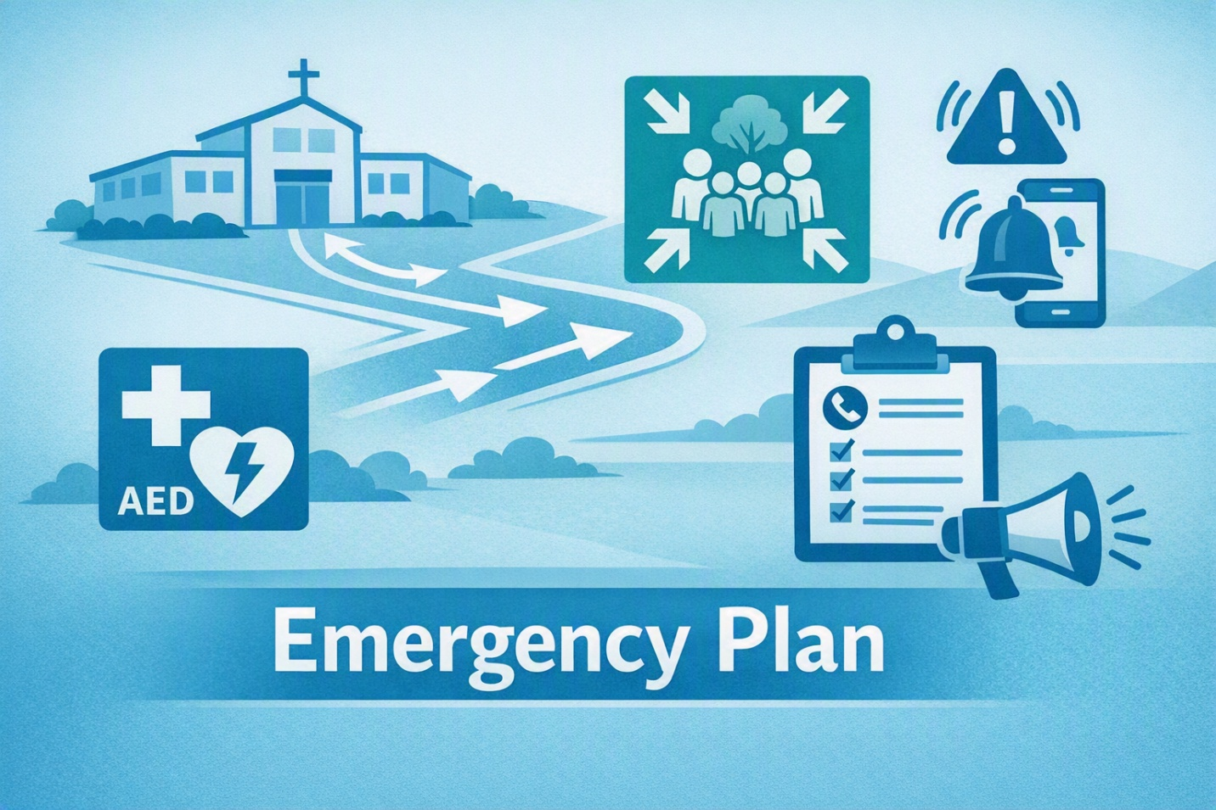
- Evacuation, Accountability, and Critical Operations
Attach current evacuation maps for each building showing primary and secondary routes, accessible routes, emergency exits, fire extinguishers, fire alarm pull stations, AEDs, first aid kits, assembly areas, utility shutoffs, and command post locations.
Evacuation Item | Site-Specific Entry
Primary assembly area | Enter response
Alternate assembly area | Enter response
Off-site evacuation location | Enter response
Command post location | Enter response
Primary accountability method | Attendance sheet ☐ Student roster ☐ Employee roster ☐ Visitor log ☐ Ministry/event list ☐ Electronic system  ☐ Other: Enter response
Person responsible for final accountability report | Enter response
Procedure for missing persons | Report immediately to: Click or tap here to enter text.  Notify first responders as directed.

Critical operations before evacuation: Only trained and designated personnel may remain briefly to shut down or secure utilities, kitchen equipment, boilers, alarm interfaces, records, cash, or other essential systems, and only when safe to do so.
Critical Operation | Designated Person | Alternate | Instructions / Location
Gas shutoff | Enter response | Enter response | Enter response
Electrical shutoff | Enter response | Enter response | Enter response
Water shutoff | Enter response | Enter response | Enter response
Kitchen / cafeteria equipment | Enter response | Enter response | Enter response
Fire alarm / sprinkler panel | Enter response | Enter response | Enter response
Records / emergency files | Enter response | Enter response | Enter response

- Child Safety, Student Release, and Family Reunification
Schools, preschools, religious education programs, youth ministry programs, and other child-serving activities should maintain current rosters, emergency contact information, authorized pickup lists, medical information, and supervision procedures. Student or child release should occur only through the approved reunification process unless directed otherwise by public safety authorities.
Reunification Item | Site-Specific Entry
Primary reunification site | Enter response
Alternate reunification site | Enter response
Request gate / check-in area | Enter response
Reunion gate / release area | Enter response
Identification required | ☐ Photo ID ☐ Authorized pickup list ☐ Emergency contact verification ☐ Other: Enter response
Student supervision area | Enter response
Records used for release | ☐ Emergency cards ☐ Student information system ☐ Class rosters ☐ Sign-out forms ☐ Other: Enter response
Bilingual / accessibility support | Enter response

- Emergency Reporting, Alarm, and Communications
Emergency Reporting. Any person discovering a fire, medical emergency, violent threat, hazardous condition, or other emergency must immediately call 911 or local emergency services when life safety is at risk, notify the parish/school main office or designated emergency line, and report the location, nature of the incident, hazards present, and persons needing assistance.
Emergency communications should be timely, accurate, coordinated, and limited to confirmed information. The Communications Lead should coordinate internal alerts, parent/guardian or parishioner notices, staff updates, public safety communications, and media inquiries consistent with location and archdiocesan procedures. See https://handbook.la-archdiocese.org/chapter-5/section-5-2/topic-5-2-10.
Audience | Method | Responsible Person | Template / Notes
Employees / Staff | PA ☐ Text ☐ Email ☐ Radio ☐Phone tree ☐ | Enter response | Enter response
Students / Program Participants | PA ☐ Classroom instruction ☐ Runners ☐ Other ☐ | Enter response | Enter response
Parents / Guardians | Text ☐ Email ☐ App ☐ Website ☐ Phone ☐ | Enter response | Enter response
☐Parishioners / Congregation | Email ☐ Website ☐ Bulletin ☐ Social media ☐ Phone ☐ | Enter response | Enter response
Public Safety Agencies | ☐ 911 ☐ Direct line ☐ Liaison | Enter response | Enter response
Media | ☐ ADLA Designated spokesperson only | Enter response | Refer inquiries to: Enter response

- Continuity of Operations and Recovery
Continuity / Recovery Item | Site-Specific Entry
Essential functions to restore first | - Enter response  - Enter response  - Enter response
Alternate operating location | Enter response
Records backup location | Enter response
Payroll / finance continuity contact | Enter response
Facility assessment lead | Enter response
Pastoral, counseling, or employee support resources | Enter response
After-action review date Select date | Enter response
Corrective action tracking method | Enter response

- Training, Drills, and Plan Maintenance
Employees should be trained on emergency reporting, alarms, evacuation routes, accountability, assigned duties, protective actions, communications, and any medical, rescue, utility, security, supervision, or reunification duties assigned to them. The plan should be reviewed when developed, when responsibilities change, when the plan changes, after major drills or incidents, and at least annually.
Exercise / Training | Frequency | Last Completed Select date | Next Due  Select date | Responsible Person
Fire drill | Enter response | Enter response | Enter response | Enter response
Earthquake drill | Enter response | Enter response | Enter response | Enter response
Lockdown / secure campus drill | Enter response | Enter response | Enter response | Enter response
Shelter-in-place drill | Enter response | Enter response | Enter response | Enter response
Reunification exercise | Enter response | Enter response | Enter response | Enter response
Tabletop exercise (TTX) | Enter response | Enter response | Enter response | Enter response
Emergency team training | Enter response | Enter response | Enter response | Enter response
AED certification | Every 2 years

Plan records to maintain: training rosters, drill logs, evacuation maps, emergency contact lists, rosters, visitor logs, incident reports, after-action reports, corrective actions, utility shutoff instructions, emergency supply inventories, and current copies of this plan.

- Appendices and Site-Specific Information
- Appendix A – Emergency Contact Directory
- Appendix B – Campus and Building Maps
- Appendix C – Evacuation Routes and Assembly Areas
- Appendix D – Utility and Critical Systems Guide
- Appendix E – Persons Requiring Assistance Procedures
- Appendix F – Student / Child Release and Reunification Form
- Appendix G – Reunification Protocol
- Appendix H – Incident Report Form
- Appendix I – Drill and Training Log
- Appendix J – Emergency Supply Inventory
- Appendix K – Communication Templates
- Appendix L – Workplace Violence Prevention Plan

Appendix F

Student / Child Release and Reunification Form
Date | Enter response | Time | Enter response
Student / Child Name | Enter response
Released To | Enter response
Relationship | Enter response | ID Verified By | Enter response
Authorized Pickup Confirmed | ☐ Yes ☐ No | Staff Initials | Enter response
Notes | Enter response

Appendix H

Incident Report Form
Date / Time | Enter response
Incident Type | ☐ Fire ☐Medical ☐ Earthquake ☐ Lockdown ☐ Missing Child ☐ Utility ☐ Other: Enter response__
Location | Enter response
Description of Incident | Enter response
Actions Taken | Enter response
Public Safety Notified | ☐ Yes ☐ No Agency / Officer: Enter response__
Injuries / Medical Response | Enter response
Follow-Up / Corrective Action | Enter response
Completed By | Enter response

Appendix I

Drill and Training Log
Date | Drill / Training Type | Participants | Observations | Corrective Action | Completed By
Enter response | Enter response | Enter response | Enter response | Enter response | Enter response
Enter response | Enter response | Enter response | Enter response | Enter response | Enter response
Enter response | Enter response | Enter response | Enter response | Enter response | Enter response

